**Movie Recommendation System**

Submitted in partial fulfilment of the requirements for the award of degree of

**BACHELOR OF ENGINEERING**

**IN**

**COMPUTER SCIENCE & ENGINEERING**



**Submitted to : -** Inderjeet Singh **Submitted by : -** Vaibhav Ahuja

**(Project Teacher) UID : -** 19BCS1065

**Project Supervisor : -** Daljeet Kaur

**E code : -** E6213

**Signature : -**

**DEPARTMENT OF COMPUTER SCIENCE & ENGINEERING**

**Chandigarh University, Gharuan**

**September 2021**

**Table Of Contents**

1. Introduction ………………………………………….3
2. Technologies Used …………………………………..4
3. Feasibility Study ……………………………………..5
4. Methodology/ Planning of work……………………...6
5. Innovation in Project …………………………………7
6. Software and Hardware Requirements ……………….7
7. Bibliography ………………………………………….8

# Introduction

One of the most used machine learning algorithms is recommendation systems. A **recommender** (or recommendation) **system** (or engine) is a filtering system which aim is to predict a rating or preference a user would give to an item, eg. a film, a product, a song, etc.

Below is a very simple illustration of how recommender systems work in the context of an e-commerce site.

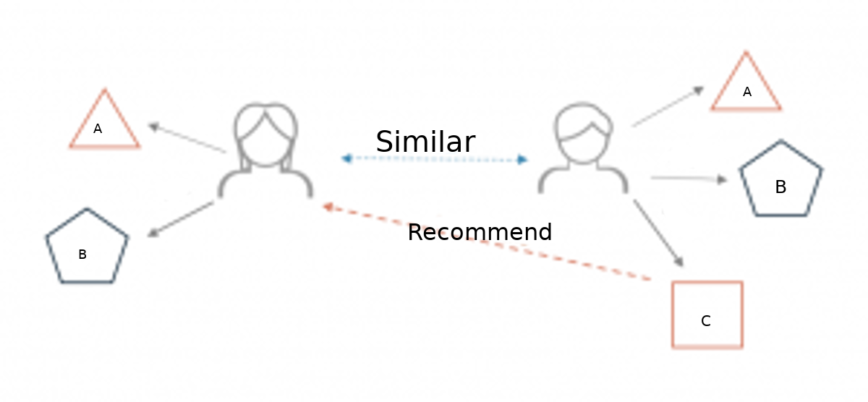

There are two main types of recommender systems:

* Content-based filters
* Collaborative filters

Content Based Recommender System recommends movies similar to the movie user likes and analyses the sentiments on the reviews given by the user for that movie. Movie recommendation system will take movie as an input from the user and recommend similar movies using content-based filters. Data sets used for the modelling of data are : - “IMDB 500 Movie Dataset (Kaggle)” , “The Movies Dataset (Kaggle)” , “Netflix Movies and shows Dataset (Kaggle)”.

# Technologies Used

1. **Python: -** Python is a an interpreted, high-level, general Python is an interpreted, high-level, general-purpose programming language. Created by Guido van Rossum and first released in 1991, Python's design philosophy emphasizes code readability with its notable use of significant whitespace. Its language constructs and object-oriented approach aim to help programmers write clear, logical code for small and large-scale projects. Python is selected as the main language ( not R) because of its’ extensive libraries.
2. **Jupyter Notebook: -** The Jupyter Notebook is an open-source web application that allows you to create and share documents that contain live code, equations, visualizations and narrative text. Uses include: data cleaning and transformation, numerical simulation, statistical modeling, data visualization, machine learning, and much more.
3. **HTML:** - HTML (hypertext markup language) is used in web development, it is used to make structure of the web page. It is the first step towards the web development.
4. **CSS: -** Cascading style sheet is used for the alignment of the content of the web page, it makes it easier for the users to read the content.
5. **JavaScript: -** It is a language made for the purpose of web development. At first it was only used for front end part but after NodeJS it is now also used in the backend part of the web pages.
6. **AJAX:** - AJAX (**A**synchronous **J**avaScript **A**nd **X**ML) allows web pages to be updated asynchronously by exchanging data with a web server behind the scenes. This means that it is possible to update parts of a web page, without reloading the whole page.
7. **Flask: -** Flask is an API of Python that allows us to build up web-applications. It was developed by Armin Ronacher. Flask’s framework is more explicit than Django’s framework and is also easier to learn because it has less base code to implement a simple web-Application.

# Feasibility Study

Feasibility refers to the practicality of the project. Before doing the project, Movie Recommendation System and analysing all the existence or required functionality of the system the first task is to do feasibility study for the project. All projects are feasible given unlimited resources and infinite time. Feasibility study includes consideration of all the possible ways to improve the solution to give the problem the proposed solution should satisfy all the user requirement and should be flexible enough so that future changes can be easily done based on the future upcoming requirement.

**Economic feasibility: -** These days it is an especially important aspect to be considered while developing a project, we decided the technology based on minimum possible cost factor. All hardware and software course must be on by the organization. Overall, we have estimated that the benefit the organization is going to receive from the proposed system will ensure early sure overcome the initial and the letter on running cost for the system.

**Technical feasibility: -** This includes the study of function performance and constraints that may affect the ability to achieve an acceptable system. For this feasibility study we studied complete functionality to be provided in the system as described in the system requirement specification and checked if everything was possible using different type of front and backend formats.

**Operational feasibility: -** No doubt the proposed system is fully GUI based that is very user-friendly and inputs to be taken all self-explanatory. layman without a proper training will be able to use the recommendation system without any difficulty. Continued deployment and scaling of the project will also not be a problem as the deployment is done on free and sustainable means.

# Methodology/ Planning of work

* First, I have decided to clear my basics about the languages I am going to use. I have opted for the Jovia course regarding the language which I am going to use as this will help us only in making the project.
* The next step would be elementary data analysis of the datasets to get an overview of the data sets we are using.
* The next step would be to data pre-processing. It will include combining all the different data sets and making them ready for modeling by data pre-processing.
* The next step would be to do the modeling and making functions for getting movies based on their content.
* The next step would be to build the front-end using HTML CSS AND JavaScrit.
* Last step would be the integration of both front end and back-end and deployment of the model.

# Innovation in Project

Current recommendation systems available are inbuild in a specific OTT platform on the contrary I am building a website which will include all the movies from various platforms. The system will also include an inbuild sentiment analysis based on the reviews given to that selected movie. Sentiment analysis will help the user to quickly get an idea about the reviews that particular movie has. It will also include additional information about like cast and small description of the cast in the movie.

# Software and Hardware Requirements

**Hardware Requirements**

* Processor: Minimum 1 GHz; Recommended 2GHz or more
* Ethernet connection (LAN) OR a wireless adapter (Wi-Fi)
* Hard Drive: Minimum 32 GB; Recommended 64 GB or more
* Memory (RAM): Minimum 1 GB; Recommended 4 GB or above

**Software Requirements**

* Python 3.4 or above
* Text Editor (Vs Code Editor)
* IDE (Spyder)
* Flask 1.1.1
* Ajax

# Bibliography

* Peng, Xiao, Shao Liangshan, and Li Xiuran. "Improved Collaborative Filtering Algorithm in the Research and Application of Personalized Movie Recommendations", 2013 Fourth International Conference on Intelligent Systems Design and Engineering Applications, 2013.
* Munoz-Organero, Mario, Gustavo A. Ramíez-González, Pedro J. Munoz-Merino, and Carlos Delgado Kloos. "A Collaborative Recommender System Based on SpaceTime Similarities", IEEE Pervasive Computing, 2010.
* Al-Shamri, M.Y.H.. "Fuzzy-genetic approach to recommender systems based on a novel hybrid user model", Expert Systems With Applications, 200810
* Hu Jinming. "Application and research of collaborative filtering in e-commerce recommendation system", 2010 3rd International Conference on Computer Science and Information Technology, 07/2010
* Xu, Qingzhen Wu, Jiayong Chen, Qiang. "A novel mobile personalized recommended method based on money flow model for stock exchange.(Researc", Mathematical Problems in Engineering, Annual 2014 Issue
* [**https://www.w3schools.com/js/js_ajax_intro.asp**](https://www.w3schools.com/js/js_ajax_intro.asp)
* [**https://jovian.ai/learn/machine-learning-with-python-zero-to-gbms**](https://jovian.ai/learn/machine-learning-with-python-zero-to-gbms)
* **https://www.tutorialspoint.com/flask/index.htm**